**LAB ACTIVITIES**

Name: Kulsoom Khurshid

Reg#: Sp20-BCS-044

Course: DATABASE SYSTEM-1

**Activity 1:**

Write the Relational algebra expressions for the following information needs over IMDB-sample Database:

1. 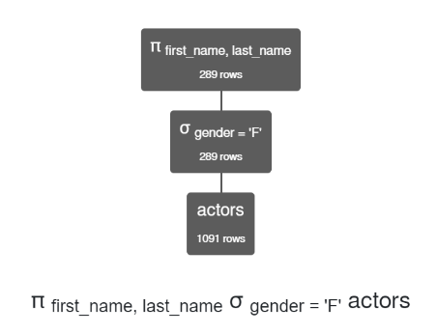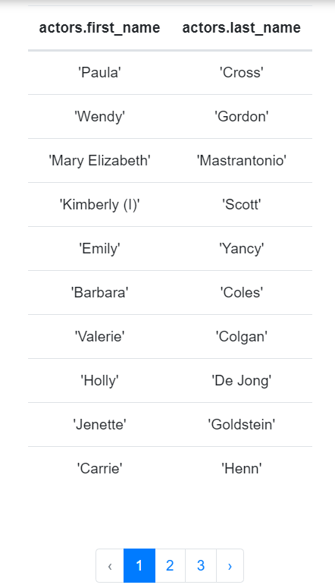list the first and last name of all the female actors.  
   **π first_name , last_name σ gender = 'F' actors**
2. List movie names along with their directors name of all the movies with a rank greater than 8.5.  
   **π movies.name, directors.first_name , directors.last_name (σ movies.id = movies_directors.movie_id ∧ rank > 8.5 (movies ⨯ (σ directors.id = movies_directors.director_id (movies_directors ⨯ directors))))**

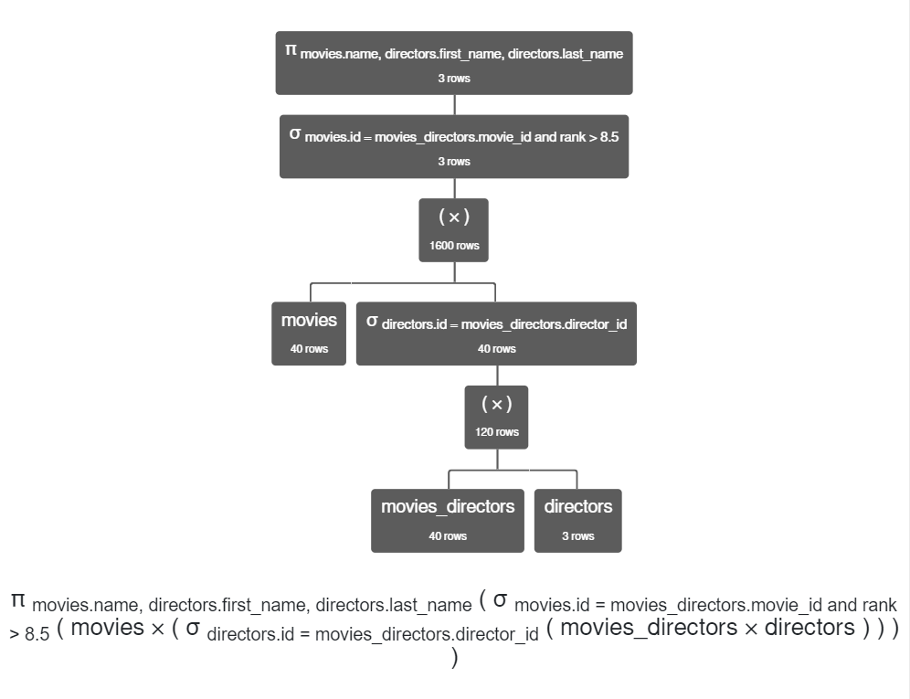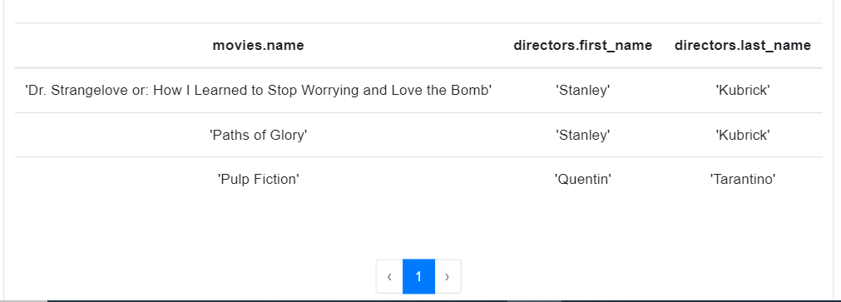

1. List titles of all the movies that are released after 2000, have a rank greater than 8, and that belong to Action genre.  
   **π movies.name σ movies.id = movies_genres.movie_id ∧ year > 2000 ∧ rank > 8 ∧ genre = 'Action' (movies ⨯ movies_genres)**

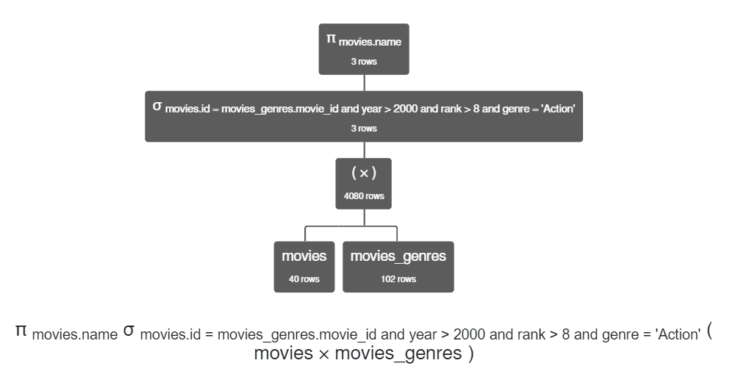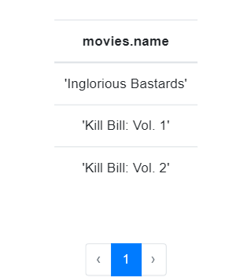

1. List the first and last names of all the actors who played a role in the movie Reservoir Dogs, and the roles they played in it.  
   **π actors.first_name, actors.last_name, roles.role (σ actors.id = roles.actor_id (actors ⨯ (σ movies.id = roles.movie_id ∧ movies.name = 'Reservoir Dogs' (movies ⨯ roles))))**

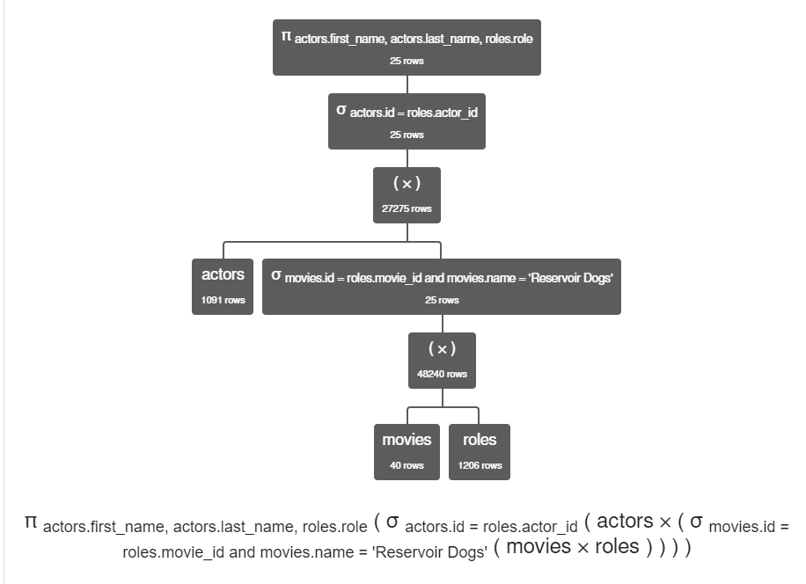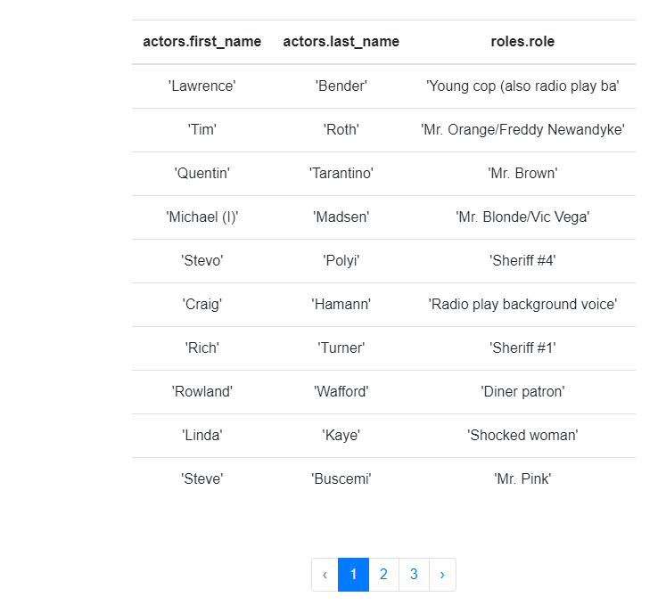

1. List the first and last names of all the actors who acted in the movies of the director Quentin Tarantino but not in the movies of director Stanley Kubrick.  
   **π actors.first_name, actors.last_name σ roles.movie_id = movies_directors.movie_id ∧ ((directors.first_name = 'Quentin' ∧ directors.last_name = 'Tarantino' ) ∨ (directors.first_name = 'Stanley' ∧ directors.last_name = 'Kubrick')) ((σ actors.id = roles.actor_id (actors ⨯ roles)) ⨯ (σ directors.id = movies_directors.director_id (directors ⨯ movies_directors)))**

**-**

**π actors.first_name, actors.last_name σ roles.movie_id = movies_directors.movie_id ∧ directors.first_name = 'Stanley' ∧ directors.last_name = 'Kubrick' ((σ actors.id = roles.actor_id (actors ⨯ roles)) ⨯ (σ directors.id = movies_directors.director_id (directors ⨯ movies_directors)))**

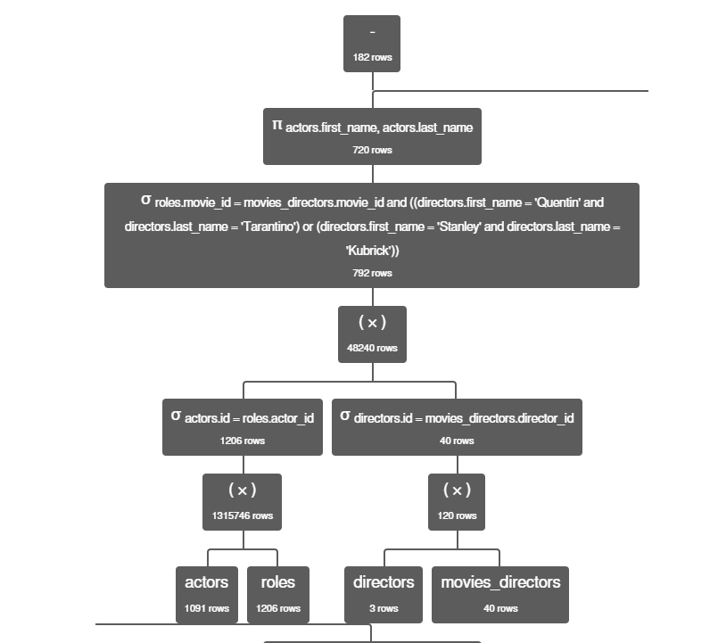

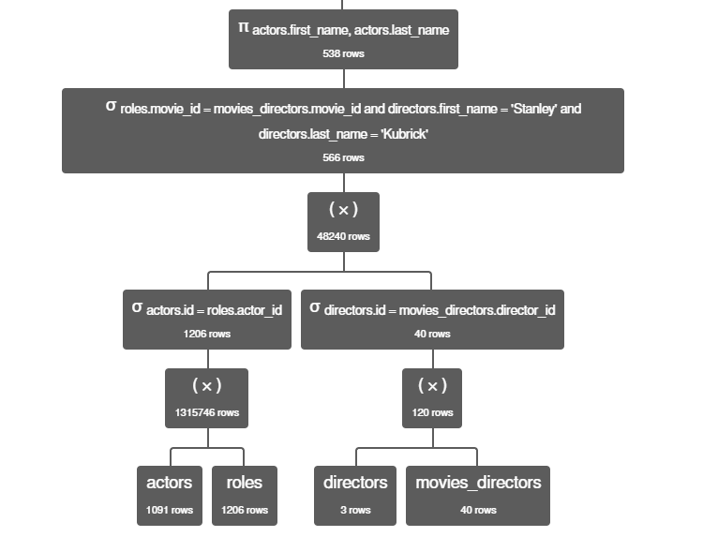

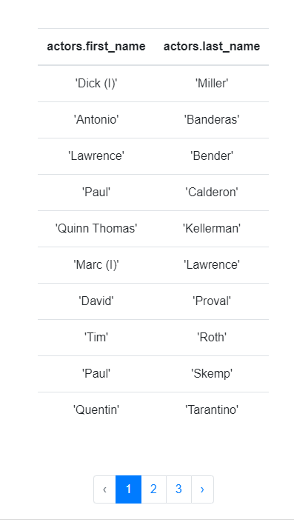

Write the Relational Algebra expressions for the following information needs over University Database:

1. Retrieve the title of the course that is pre-req of 'Database System Concepts'.

**σ prereq.prereq_id = course_id (course x π prereq_id**

**(σ prereq.course_id= course.course_id (prereq x (σ title = 'Database System Concepts' (course)))))**

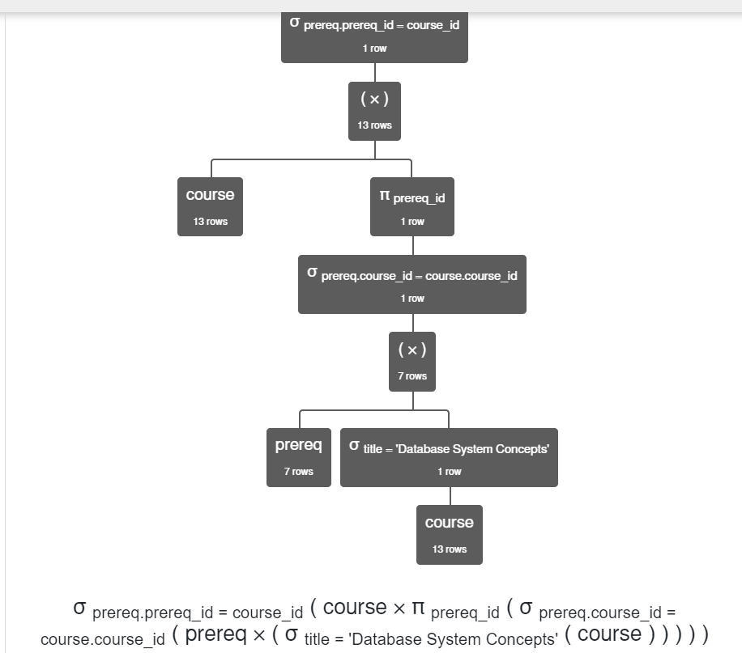

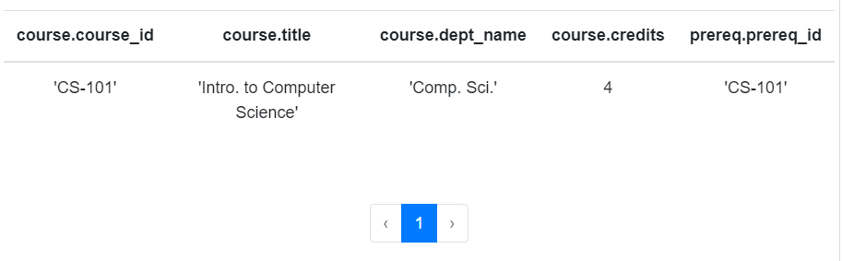

1. Retrieve the semester and the year in which 'Einstein' taught the course 'Physical Principles'.  
   **π semester , year (σ teaches.ID = instructor.ID ∧ instructor.name = 'Einstein' (instructor ⨯ (σ course.course_id = teaches.course_id ∧ course.title = 'Physical Principles' (course ⨯ teaches))))**

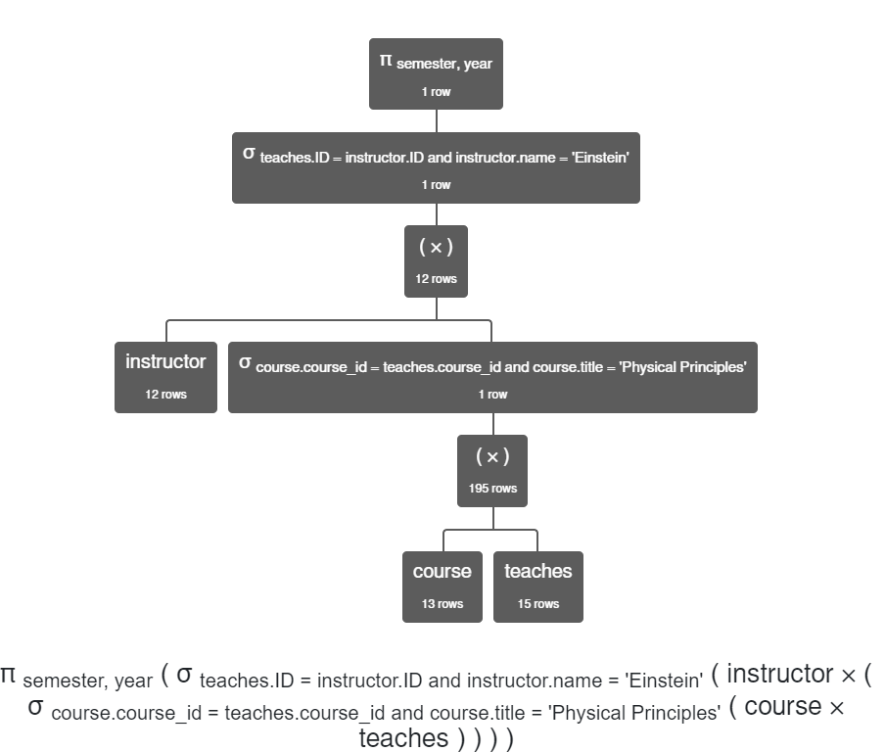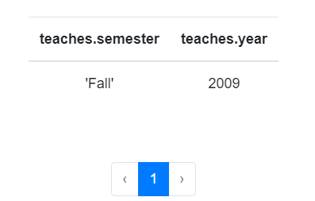

1. Retrieve the ID and the title of all the courses taken by 'Shankar' in 'Fall 2009'.  
   **π course.course_id, course.title (σ course.course_id = takes.course_id (course ⨯ (σ student.ID = takes.ID ∧ semester = 'Fall' ∧ year = 2009 ∧ student.name = 'Shankar' (student ⨯ takes))))**

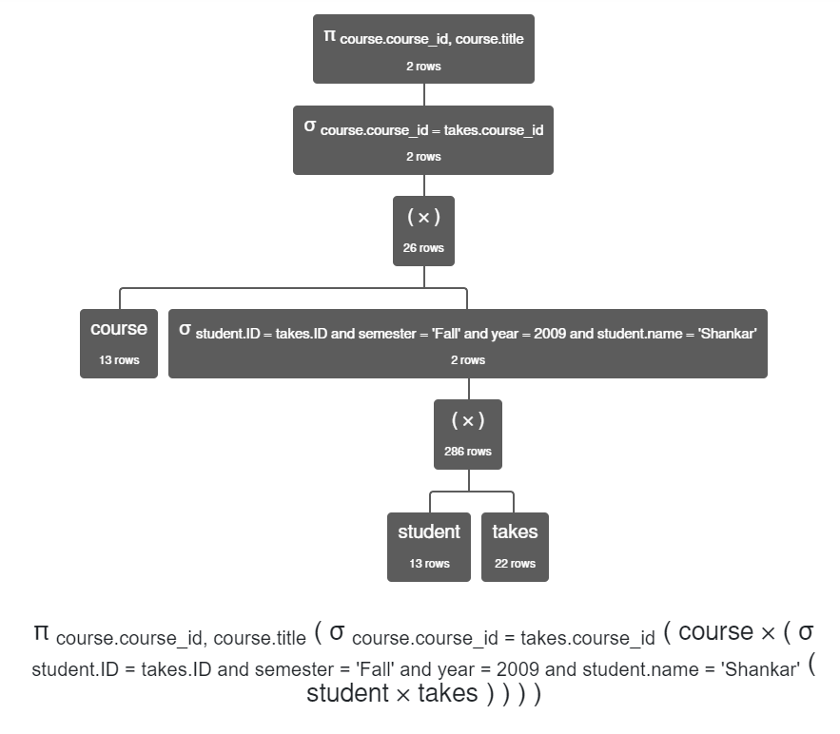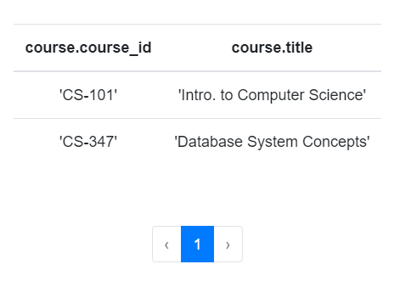

1. List the name of students who did not take any course in 'Fall 2009'.

**π student.name student - (π student.name (σ takes.ID = student.ID ∧ semester = 'Fall' ∧ takes.year = 2009 (student ⨯ takes)))**

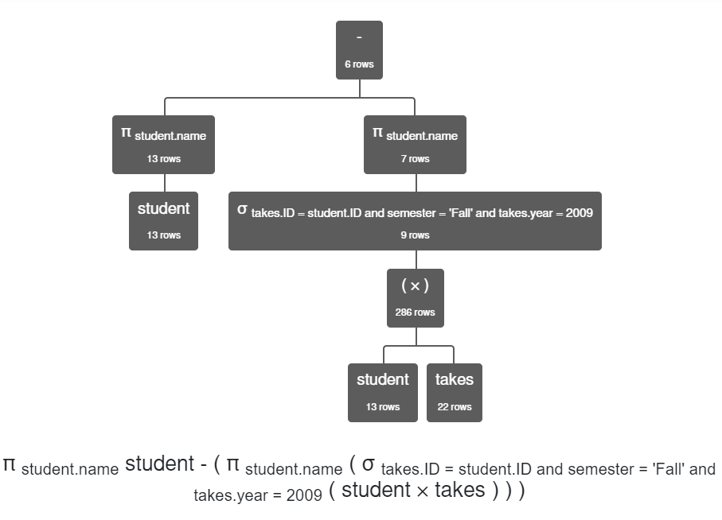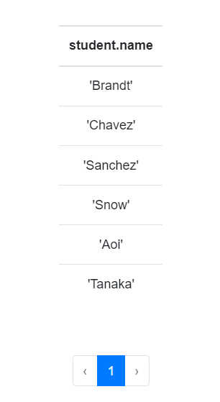

1. Find building, room number, and capacity of all classrooms in which student 'Tanaka' took all his classes.

**π classroom.building , classroom.room_number , classroom.capacity σ student.dept_name = department.dept_name ∧ student.name = 'Tanaka' (σ department.building = classroom.building (classroom ⨯ department) ⨯ student)**

